EXPERIMENT NO. 6: ONLINE CAKE ORDERING SYSTEM (BUY A CAKE)
AIM:
To design and implement an online cake ordering web platform allowing customers to browse cakes by category and flavor, customize cake weight and messages, add items to cart, enter delivery schedules, and track live order fulfillment statuses.
PSEUDOCODE (IN 6 SIMPLE POINTS):
Step 1: Initialize the cake catalog with flavors (Black Forest, Red Velvet, Truffle), occasion tags, and base prices.
Step 2: Display an attractive product showcase with filters for categories, flavor preferences, and price ranges.
Step 3: Enable customers to customize selected cakes by choosing weight (0.5 kg, 1 kg, 2 kg) and entering custom piped messages.
Step 4: Maintain an interactive shopping cart with functionalities to add items, modify quantities, and calculate order totals.
Step 5: Capture recipient delivery address, delivery date, preferred delivery time slot, and simulate payment confirmation.
Step 6: Equip admin with controls to add new cake items, adjust prices, and update logistics order status (Baking, Dispatched, Delivered).
SOURCE CODE:
<!DOCTYPE html>
<html lang="en">
<head>
<meta charset="UTF-8">
<title>Buy a Cake - Sweet Treats Online</title>
<style>
body { font-family: 'Segoe UI', Tahoma, sans-serif; margin: 0; background: #fff5f5; color: #4a5568; }
header { background: #e53e3e; color: white; padding: 20px; text-align: center; }
.container { max-width: 1000px; margin: 25px auto; padding: 20px; background: white; border-radius: 10px; box-shadow: 0 4px 12px rgba(0,0,0,0.06); }
.cake-grid { display: grid; grid-template-columns: repeat(auto-fit, minmax(260px, 1fr)); gap: 20px; margin-top: 20px; }
.card { border: 1px solid #fed7d7; border-radius: 8px; padding: 15px; text-align: center; background: #fffaf0; }
.card h3 { margin: 10px 0; color: #9b2c2c; }
select, input, button { width: 100%; padding: 9px; margin: 6px 0; border: 1px solid #cbd5e0; border-radius: 4px; box-sizing: border-box; }
button { background: #e53e3e; color: white; font-weight: bold; border: none; cursor: pointer; }
button:hover { background: #c53030; }
.cart-box { margin-top: 30px; border-top: 2px dashed #e2e8f0; padding-top: 20px; }
.status-pill { display: inline-block; padding: 5px 12px; background: #feebc8; color: #c05621; border-radius: 20px; font-weight: bold; }
</style>
</head>
<body>
<header>
<h2>Sweet Delights - Online Cake Bakery</h2>
<p>Fresh artisanal cakes delivered right to your doorstep</p>
</header>
<div class="container">
<h3>Featured Specialty Cakes</h3>
<div class="cake-grid">
<div class="card">
<h3>Belgian Choco Truffle</h3>
<p>Rich dark chocolate ganache cake</p>
<label>Weight:</label>
<select id="w1">
<option value="1">0.5 Kg - Rs. 450</option>
<option value="2">1.0 Kg - Rs. 850</option>
</select>
<input type="text" id="m1" placeholder="Custom Inscription on Cake">
<button onclick="addToCakeCart('Belgian Choco Truffle', 'w1', 'm1', 450)">Add to Cart</button>
</div>
<div class="card">
<h3>Royal Red Velvet Heart</h3>
<p>Cream cheese frosting with velvet crumb</p>
<label>Weight:</label>
<select id="w2">
<option value="1">0.5 Kg - Rs. 550</option>
<option value="2">1.0 Kg - Rs. 990</option>
</select>
<input type="text" id="m2" placeholder="Custom Inscription on Cake">
<button onclick="addToCakeCart('Royal Red Velvet', 'w2', 'm2', 550)">Add to Cart</button>
</div>
</div>
<div class="cart-box">
<h3>Your Shopping Cart & Delivery Checkout</h3>
<div id="cartItems">Your cart is currently empty.</div>
<h4 id="grandTotal" style="color: #e53e3e;">Total: Rs. 0</h4>
<div id="deliverySection" style="display:none; max-width: 500px;">
<input type="text" id="delivAddress" placeholder="Complete Delivery Address" required>
<label>Preferred Delivery Date & Time:</label>
<input type="datetime-local" id="delivTime" required>
<button onclick="placeCakeOrder()">Place Order & Pay</button>
</div>
<div id="orderStatusBox"></div>
</div>
</div>
<script>
let cakeCart = [];
function addToCakeCart(name, wId, mId, basePrice) {
let mult = document.getElementById(wId).value;
let weight = mult == '1' ? '0.5 Kg' : '1.0 Kg';
let price = mult == '1' ? basePrice : (basePrice * 1.8);
let msg = document.getElementById(mId).value.trim() || 'Happy Birthday!';
cakeCart.push({ name, weight, price, msg });
renderCart();
}
function renderCart() {
let container = document.getElementById('cartItems');
if(!cakeCart.length) {
container.innerHTML = 'Your cart is empty.';
document.getElementById('grandTotal').innerText = 'Total: Rs. 0';
document.getElementById('deliverySection').style.display = 'none';
return;
}
let html = '<ul style="list-style:none; padding:0;">';
let sum = 0;
cakeCart.forEach((item, idx) => {
sum += item.price;
html += `<li style="padding:8px 0; border-bottom:1px solid #eee;">
<b>${item.name}</b> (${item.weight}) - Rs. ${item.price} | Inscription: "<i>${item.msg}</i>"
<a href="javascript:void(0)" onclick="removeCakeItem(${idx})" style="color:red; margin-left:10px;">[Remove]</a>
</li>`;
});
html += '</ul>';
container.innerHTML = html;
document.getElementById('grandTotal').innerText = 'Total: Rs. ' + sum.toLocaleString();
document.getElementById('deliverySection').style.display = 'block';
}
function removeCakeItem(idx) {
cakeCart.splice(idx, 1);
renderCart();
}
function placeCakeOrder() {
let addr = document.getElementById('delivAddress').value.trim();
if(!addr) return alert('Please enter delivery address');
let ordId = 'CK-' + Math.floor(1000 + Math.random() * 9000);
document.getElementById('orderStatusBox').innerHTML = `
<div style="background:#def7ec; color:#03543f; padding:15px; border-radius:6px; margin-top:15px;">
<h4>Order Placed Successfully!</h4>
<p><b>Order ID:</b> ${ordId} | <b>Delivery Address:</b> ${addr}</p>
<p><b>Status:</b> <span class="status-pill">Baking in Progress</span></p>
<small>You will receive SMS delivery notifications once out for dispatch.</small>
</div>`;
cakeCart = [];
renderCart();
}
</script>
</body>
</html>
Output:
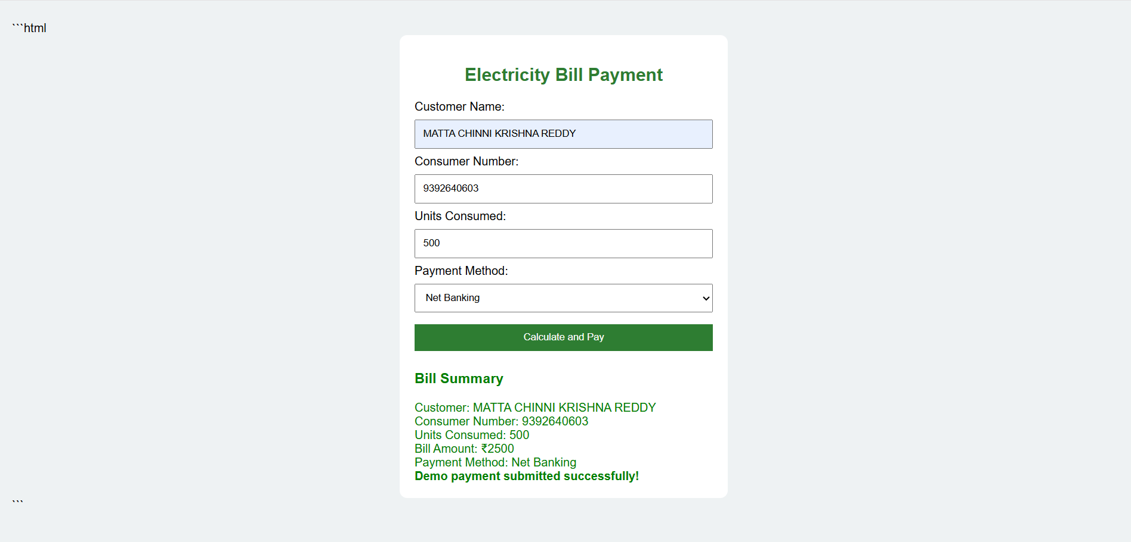
RESULT:
Thus, the online cake ordering system was successfully designed and tested, implementing flavor selection, customized text inscription, shopping cart calculations, and live delivery status tracking.

